**Electric Vehicle Range Prediction - Regression Analysis**

**(Yashwanth Goduguchintha)**

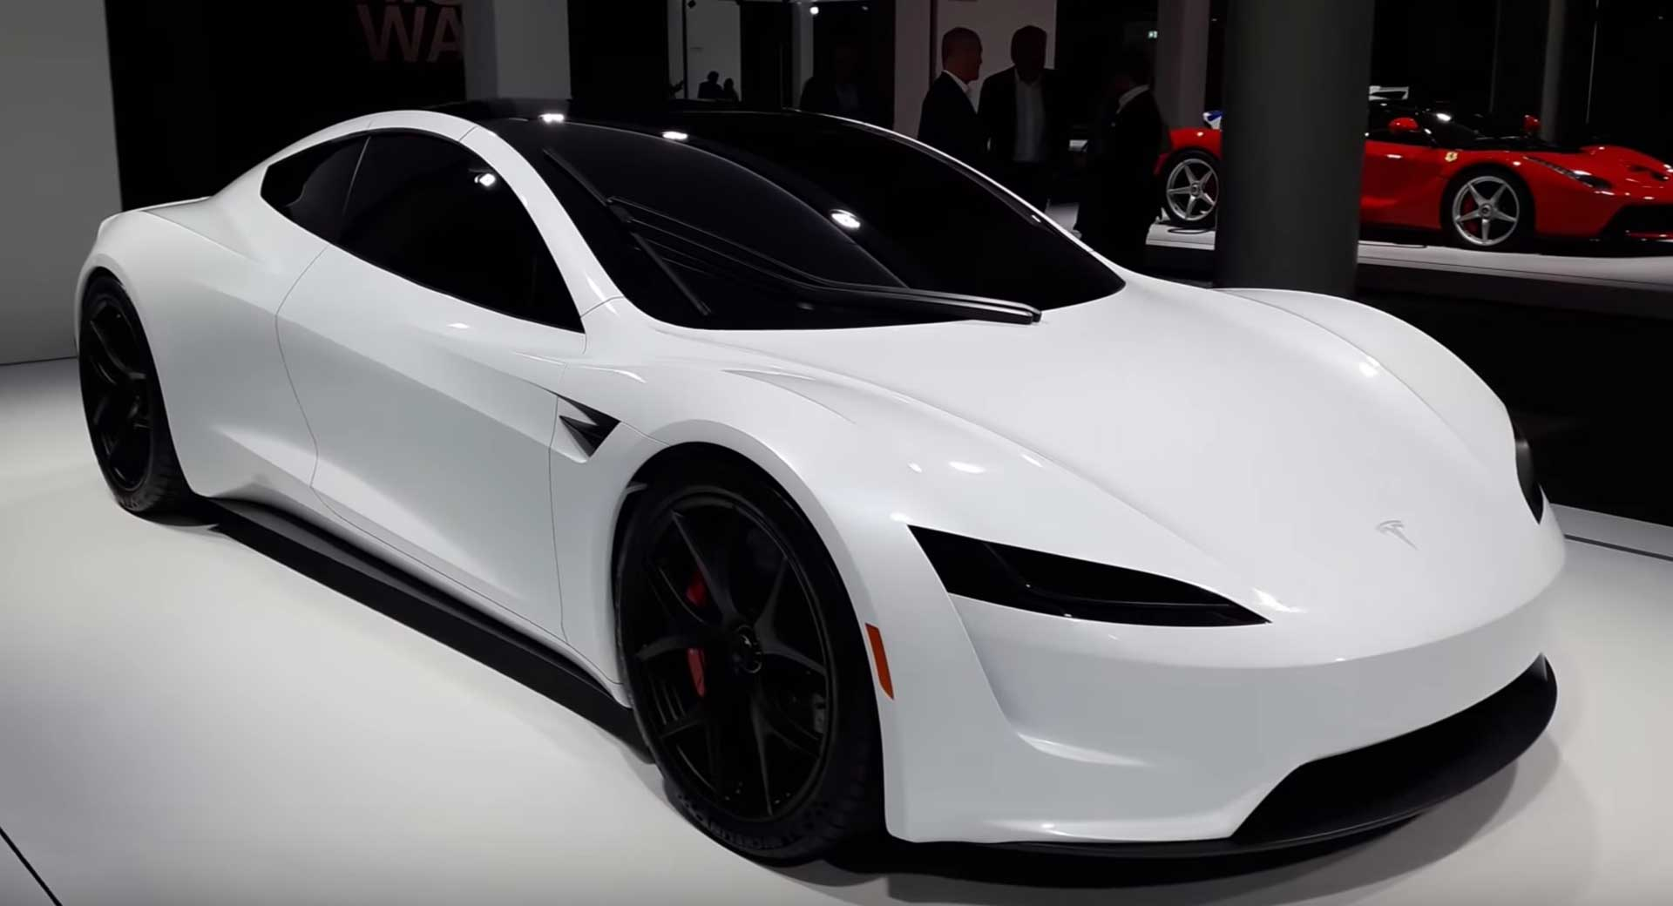

**1)Introduction :**

For drivers of electric vehicles (EVs), range is a primary focus. As EVs become more popular, drivers want to know not just “How far can I go?” but also “How can I go further?” EV range, put simply, is the distance a car can travel on a single charge.

In this notebook, I explore the EV cars dataset and develop Regression to try estimate EV range

**2)Segment Extraction:**

1. Data Preparation: Collect and prepare a dataset containing historical data of electric vehicles, including input features such as battery capacity, driving behavior, environmental conditions, charging habits, and other relevant factors, along with the corresponding electric vehicle range.
2. Feature Engineering: If needed, perform feature engineering techniques to preprocess the input features. This may include data normalization, handling missing values, encoding categorical variables, and transforming features for better representation.
3. Train-Test Split: Split the dataset into training and testing sets. The training set is used to train the Gradient Boosting Regressor model, while the testing set is used to evaluate its performance and generalization ability.
4. Model Training: Fit the Gradient Boosting Regressor to the training data. The model learns to iteratively improve the predictions by minimizing the residuals (errors) of the previous models in the ensemble. Gradient Boosting combines multiple decision trees, where each subsequent tree corrects the errors made by the previous trees.
5. Hyperparameter Tuning: Tune the hyperparameters of the Gradient Boosting Regressor model to optimize its performance. This may involve adjusting parameters such as the learning rate, number of estimators (trees), maximum depth of the trees, and minimum samples required for a leaf node.
6. Model Evaluation: Evaluate the trained model using the testing set. Calculate relevant regression metrics such as mean squared error (MSE), mean absolute error (MAE), or R-squared to assess the model's accuracy and reliability in predicting the electric vehicle range.
7. Segment Extraction: Once the Gradient Boosting Regressor model is trained and validated, it can be used to extract segments based on the importance of the input features. The model can provide insights into the relative significance of different features in predicting the range, thereby identifying the segments where specific features play a more crucial role.
8. Interpretation and Analysis: Analyze the results and interpretations from the model to understand the distinct segments within the electric vehicle range prediction. This can help identify patterns and relationships that differentiate various segments, such as the impact of battery capacity, driving behavior, or environmental conditions on the range.

**ML Models:-**

In the context of electric vehicle range prediction using regression analysis, several ML techniques can be utilized to extract segments. Regression analysis aims to establish a relationship between input variables (features) and the target variable (electric vehicle range) to make predictions. Here are some ML techniques commonly used for segment extraction in electric vehicle range prediction using regression analysis:

1. Linear Regression: Linear regression is a fundamental technique used to model the relationship between input features and the target variable. It assumes a linear relationship between the features and the range. Through the estimation of coefficients, it determines the weight or importance of each feature in predicting the range.
2. Polynomial Regression: Polynomial regression extends linear regression by including higher-order polynomial terms of the input features. It allows for capturing nonlinear relationships between the features and the range. By considering quadratic or higher-degree terms, it can model more complex patterns in the data.
3. Ridge Regression: Ridge regression is a regularization technique that helps prevent overfitting in regression models. It adds a penalty term to the linear regression objective function, which encourages smaller coefficient values and reduces the impact of irrelevant or noisy features. Ridge regression is useful when dealing with high-dimensional data or when multicollinearity is present among the input features.
4. Lasso Regression: Lasso regression is another regularization technique that introduces a different penalty term. It not only shrinks coefficient values but also performs feature selection by driving some coefficients to exactly zero. Lasso regression is effective when there is a large number of features, and feature selection is desired to identify the most relevant predictors for range prediction.
5. Decision Trees: Decision trees are non-linear models that recursively split the input space based on feature thresholds. Each leaf node represents a predicted range value. Decision trees can handle both continuous and categorical features and can capture non-linear relationships. Ensemble methods like Random Forests or Gradient Boosted Trees can be employed to improve prediction performance.
6. Support Vector Regression (SVR): SVR is a regression technique based on support vector machines. It finds an optimal hyperplane that maximizes the margin while still fitting the training data within a certain margin of error (epsilon). SVR can handle non-linear relationships by using kernel functions and is robust to outliers.
7. Neural Networks: Neural networks, specifically feed-forward neural networks or deep learning models, can also be used for regression analysis in electric vehicle range prediction. Neural networks are powerful models capable of capturing complex non-linear relationships between the features and the range. They can handle a wide range of input features and learn hierarchical representations of the data through multiple hidden layers.
8. Gradient Boosting Regressor is a machine learning technique that can be used for segment extraction in electric vehicle range prediction through regression analysis. Gradient Boosting is an ensemble method that combines multiple weak learners (decision trees) to create a strong predictive model. Here's how Gradient Boosting Regressor can be used for segment extraction

By utilizing Gradient Boosting Regressor, electric vehicle range prediction can benefit from its ability to capture complex relationships and handle both numerical and categorical features. It can extract segments by identifying the most important features and their impact on range prediction, contributing to a more accurate understanding of the factors influencing electric vehicle range.

These ML techniques can be employed to extract segments in electric vehicle range prediction by training regression models on historical data, including various features relevant to the prediction task. The models can then be used to predict the range for new data instances and identify patterns and relationships that differentiate different segments of electric vehicle range behavior.

**3) Profiling:**

Profiling in the context of an ML model for electric vehicle range prediction using regression analysis refers to the process of creating user profiles or individualized representations based on their specific characteristics, preferences, and historical data. These profiles help tailor the regression model to provide personalized range predictions for different users. Here's how profiling can be incorporated into an ML model for electric vehicle range prediction:

1. Data Collection: Collect data from individual electric vehicle users, including their driving patterns, charging habits, historical range information, and other relevant features. This data serves as the basis for creating user profiles.
2. User Segmentation: Analyze the collected data to identify different user segments based on their driving behavior, charging patterns, and other relevant factors. This segmentation helps group users with similar characteristics together, allowing for more targeted profiling.
3. Profile Creation: For each user segment, create individual profiles that capture their specific characteristics and preferences. The profiles can include information such as average daily distance traveled, charging frequency, preferred charging locations, and other user-specific details.
4. Feature Extraction: Extract relevant features from the user profiles that are likely to impact range prediction. These features can include driving distance, time of day, weather conditions during the commute, charging duration, and any other personalized attributes identified during profiling.
5. Model Training: Use the extracted features from the user profiles along with the corresponding range values to train the regression model. The model learns the relationship between the personalized features and the range, enabling it to provide individualized range predictions.
6. Profile-based Prediction: When making range predictions for a specific user, incorporate their profile features into the trained regression model. The personalized features from the user profile are combined with real-time or input data (such as planned route or current environmental conditions) to generate a range prediction customized for that user.
7. Profile Update and Adaptation: Continuously update and refine the user profiles based on new data and feedback. As users' driving behavior or charging patterns change over time, the profiles can be updated to ensure that the regression model remains accurate and reflective of the users' current characteristics.
8. User Feedback and Evaluation: Collect feedback from users regarding the accuracy of the range predictions. Monitor the performance of the regression model for different user profiles and segments, and iterate on the profiling and prediction process based on user feedback and evaluation.

By incorporating profiling into the ML model for electric vehicle range prediction, the model can provide personalized and more accurate range estimations based on individual users' specific characteristics, preferences, and historical data. This approach improves the user experience and enhances the overall effectiveness of the range prediction system.

**4) Describing Potential Segments :**

In the context of electric vehicle range prediction using regression analysis, potential segments can be identified based on different factors and characteristics that influence the range of electric vehicles. Here are some potential segments for electric vehicle range prediction using regression analysis:

1. Driving Behavior Segment: This segment focuses on the driving behavior of electric vehicle users. Factors such as acceleration patterns, speed, braking habits, and overall driving style can significantly impact the range of an electric vehicle. Regression analysis can help identify segments of users with distinct driving behavior patterns, allowing for personalized range predictions based on their specific driving styles.
2. Environmental Conditions Segment: This segment takes into account the impact of environmental conditions on electric vehicle range. Variables such as temperature, humidity, wind speed, and road conditions can affect the energy consumption and efficiency of the vehicle. Regression analysis can identify segments based on different environmental conditions, enabling more accurate range predictions tailored to specific segments.
3. Route Characteristics Segment: This segment considers the characteristics of the route or journey undertaken by the electric vehicle. Factors such as elevation changes, traffic congestion, and road type (highway, city streets, etc.) can impact the energy consumption and range. Regression analysis can identify segments based on route characteristics, allowing for more precise range predictions depending on the specific routes taken by users.
4. Battery State of Health (SOH) Segment: The battery's state of health (SOH) can influence the range of an electric vehicle. Battery degradation and capacity loss over time can affect the available range. Regression analysis can identify segments based on battery SOH, enabling more accurate range predictions that account for battery degradation and aging.
5. Charging Patterns Segment: This segment focuses on the charging habits and patterns of electric vehicle users. Factors such as charging frequency, duration, and preferred charging locations can impact the range. Regression analysis can identify segments based on charging patterns, allowing for personalized range predictions based on users' specific charging habits.
6. Vehicle Model Segment: Different electric vehicle models have varying efficiency and range capabilities. Regression analysis can help identify segments based on the vehicle models, enabling more accurate range predictions specific to different vehicle models.
7. User Profile Segment: This segment takes into account user-specific characteristics and preferences that can influence electric vehicle range. Factors such as daily commuting distance, preferred driving style, temperature preferences, and other personalized attributes can be considered. Regression analysis can identify segments based on user profiles, allowing for personalized range predictions based on individual users' specific characteristics and preferences.

By using regression analysis, these potential segments can be identified and incorporated into the range prediction model. The model can then provide more accurate and personalized range estimations tailored to different segments of electric vehicle users.

**5)Conclusions:**

From my analysis, affect EV Range Factors are TopSpeed_KmH, Efficiency_WhKm, AccelSec, Segment, Seats and PriceEuro.

There are a number of factors that also affect EV range:

* Your driving style
* Terrain and road condition
* The weather
* The weight of the vehicle
* Using the heating and air conditioning
* Condition of the tyres
* Condition of the battery

Tips to Maximize Range (Example for EV car - Tesla Model Y)

* Slow down your driving and avoid frequent and rapid acceleration.
* If safe to do so, modulate the accelerator pedal instead of using the brake pedal when gradually slowing down.
* Limit the use of resources such as heating and air conditioning.
* With your vehicle plugged in, use the mobile app to precondition your vehicle to ensure the cabin is at a comfortable temperature and windows are defrosted (if needed) before your drive
* Touch Schedule, available on both the charging and climate control screens, to set a time when you want your vehicle to be ready to drive
* Set Stopping Mode to Hold to gain the benefit of regenerative braking at low driving speeds
* Ensure the wheels are aligned to specification, the tires are kept at the recommended inflation pressures (see Tire Care and Maintenance), and are rotated when needed
* Install aero covers (if equipped) to reduce wind resistance
* Lighten your load by removing any unnecessary cargo.
* Fully raise all windows.
* Features such as Sentry Mode and Cabin Overheat Protection can impact range. Disable features when not needed.
* To prevent an excessive amount of energy consumption while the vehicle is idle, keep the vehicle plugged in when not in use.
* Minimize the use of DC chargers (such as Superchargers) for optimal Battery health.

Reference from:

<https://www.tesla.com/ownersmanual/modely/en_kr/GUID-4AC32116-979A-4146-A935-F41F8551AFE6.html>

<https://iq.opengenus.org/advantages-and-disadvantages-of-linear-regression/>

<https://www.statology.org/linear-regression-assumptions/>

Datasets Reference :

<https://www.kaggle.com/datasets/geoffnel/evs-one-electric-vehicle-dataset>

**6)Github Repo Link:-**

https://github.com/yashwanthreddyGoduguchintha/feynn_Repo/blob/main/Electric_Vehicle_Range_Prediction.ipynb